Scout It



**Scout It!**

Several sports organizations rely almost exclusively on human expertise to determine game strategy. talent scouting. In disciplines such as basketball, it is still believed that domain experts (coaches, managers, and scouts) can effectively convert collected data into usable knowledge. The sports industry, especially in the NBA, has a longer tradition of collecting statistical data. In recent years, new technologies (layered visualization player analysis, player position tracking, s, etc.) have offered additional advantages, such as predicting particular player matchups and forecasting how an athlete might perform under specific conditions.

The **Scout It!** website tracks basketball statistics to help coaches in many ways. Most importantly, it gives you hard data to back up your claims. Instead of simply telling your team “we didn’t fight hard enough on the boards” after the game, you’ll be able to go to your team with real statistics and that confirm your comments.  

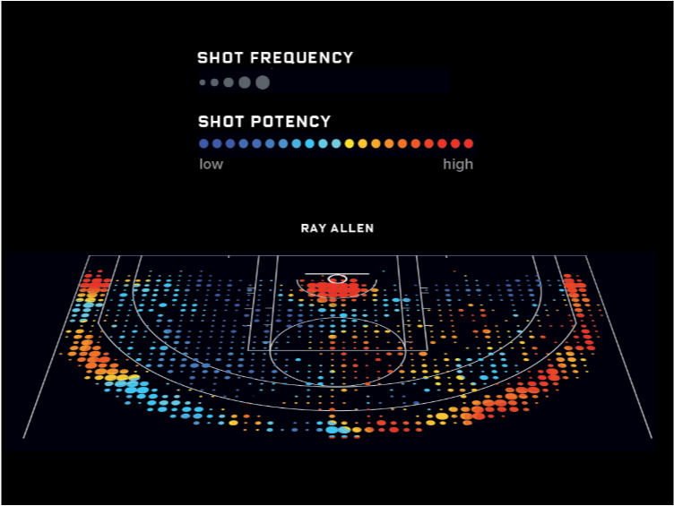

<https://stats.nba.com/>

<https://randomnerds.com/how-to-create-nba-shot-charts-in-python-just-like-kirk-goldsberry/>

<https://www.lineups.com/nba/lineups>

<http://savvastjortjoglou.com/nba-shot-sharts.html>